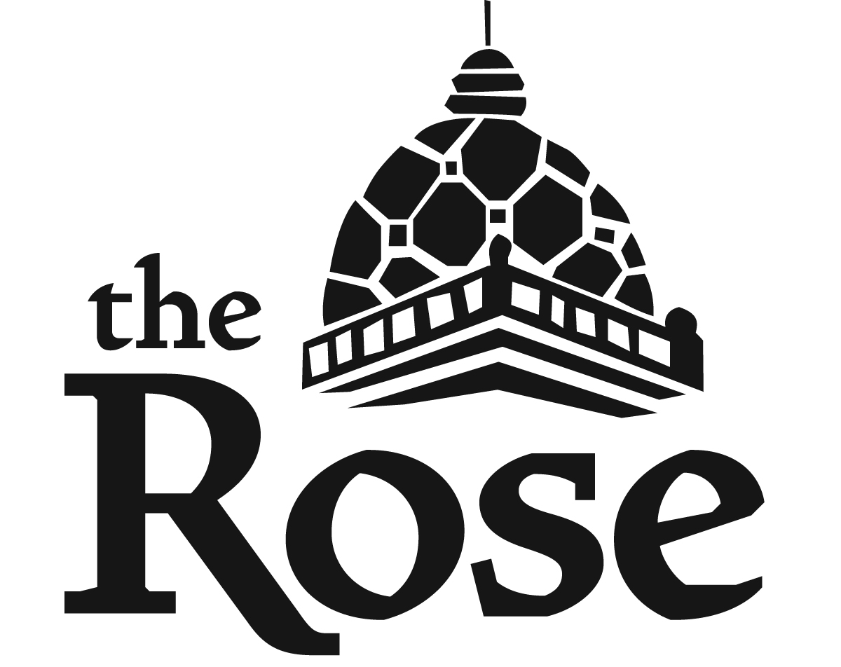

Omaha Theater Company

Social Media Protocol

At The Rose, we understand social media can be a fun and rewarding way to share your life and opinions with family, friends and co-workers around the world. We hope that you are enthusiastic about your role at the theater and appreciate that you may want to share your experiences with your online community. However, social media presents certain risks and carries with it certain responsibilities. Whether you log in to Twitter, Yelp, Wikipedia, Instagram, Facebook, Snapchat or comment on online media stories or YouTube videos – these guidelines are meant to assist you in making responsible decisions about your use of social media.

The Rose prides itself on being a family-friendly environment concerned with the positive development and well-being of children. Theater employees are expected to help continue the reputation the theater has built as a safe environment for young people to explore their creativity and develop a love of performing arts. Rose employees should safeguard the image of The Rose in both their personal and professional endeavors. This includes the use of social media. We offer these guidelines to employees who participate in online commentary.

Social Media Guidelines

PER THE ROSE THEATER EMPLOYEE HANDBOOK:
Employees should remember that any messages or information sent on company provided facilities to one or more individuals via an electronic network – for example, Internet mailing lists, bulletin board and online services – are statements identifiable and attributable to the Theater. Participation in online forums, blogging and social networking on company computers or company time may be a violation of this policy. Employees who participate in online forums, blogging or social networking in personal time may not engage in any unlawful communications regarding the company, its employees or customers; must not engage in any improper communications of confidential information, trade secrets or securities information; must not infringe upon any copyrighted or protected information or material; and must not engage in any communications that violate the company’s anti-discrimination policy or any other company policy.

Social media includes all means of communicating or posting information or content of any sort on the Internet, including to your own or someone else's web log or blog, journal or diary, personal web site, social networking web site, web bulletin board or a chat room, as well as any other form of electronic communication. As new forms of social media are developed, you should still follow the spirit of these guidelines to fit new technology.

General recommendations

It is highly recommended that employees keep work-related social media accounts separate from personal accounts. Rose employees must not “friend,” connect with or post to Rose students under the age of 18 on a personal social media account. We acknowledge that social media may be the best way to communicate with some students, particularly teens. This communication should take place ONLY via professional social media accounts. Employees must maintain healthy professional boundaries.

Employees should implement appropriate privacy blocks on all social media accounts to ensure that “non-friends” cannot view their social media websites and the privacy of the Theater is not inadvertently compromised. Be aware that certain elements of social media are never private, such as a profile photo or cover image.

Suggested privacy settings: It is recommended that Rose staff keep their personal pages limited to Friends only or to utilize the site’s filtering tools to limit who can view postings, especially those of a personal nature. Remember that you are a role model to the young people whom we serve and that these individuals are frequent users of social media. Please do your best to make sure that any public posts that they may see reflect the high ideals of the theater.

If an employee wishes to post any information or image related to The Rose on his or her social media website, the employee is reminded to keep his or her postings consistent with The Rose's mission, values and policies.

Post only appropriate and respectful content

Maintain the confidentiality of The Rose and private or confidential information. Confidential information may include information regarding:
- season planning
- unannounced plans for the theater
- information on show designs not yet cleared for public knowledge
- strategic plans
- ticket sales numbers
- member survey results
- unpublished grant activities
- donor solicitations
- other privileged information

Do not post internal reports, policies, procedures or other internal business-related communication.

PER THE ROSE THEATER EMPLOYEE HANDBOOK:
Improper use or disclosure of a trade secret or confidential business information will be subject to disciplinary action, up to and including termination of employment and legal action. This applies even if no benefit is received from releasing the information.

Associates shall not use E-mail or the Internet to send or request the receipt of the Theater’s or any customer’s trade secret, sensitive or otherwise confidential or proprietary information.

Never comment on anything related to legal matters, litigation, unpublished financial information, police investigations or any parties that The Rose may be in negotiations or litigation with.

Never participate in social media when the topic discussed may be considered a crisis situation. Even anonymous comments may be traced back to you or The Rose. Refer all social media activity around crisis topics to the Marketing Director, Artistic Director or Managing Director.

If you are unsure about the sensitivity of a particular subject, seek advice from the Marketing Director before talking about it online or simply refrain from the conversation.

Be smart about protecting yourself, your privacy and The Rose's confidential information. What you publish is widely accessible and will be around for a long time, so consider the content carefully. The Internet has a long memory.

In short – if it gives you pause – pause rather than publish!

You may provide unique, individual perspectives on non-confidential activities at The Rose. People outside the theater are interested in our activities, and we want to encourage them to learn more about The Rose and performing arts in general. You may answer questions and post responses on topics on which you are well informed. Keep the audience in mind and protect the privacy of the theater.

Think of it this way: if you were asked the question during a Q&A on stage, what would your response be? What would you say and what information would you hold back? Social media is a public forum, just like our stage. If you wouldn't state the information while standing in front of a full house, don't post it online.

Do not post information about a person or another business unless you have the right to do so, taking privacy concerns into account. For example, ask permission before posting someone's picture in a social network or publishing in a blog a conversation that was meant to be private.

An important note about photographs: As a child-centric non-profit organization, parents in our community entrust their children to us. We take this responsibility seriously. The Rose acknowledges that some parents choose not to allow their children's image on social media. We also recognize that posting children's pictures or videos online may have a negative impact on some students.

Children's photos may be posted on The Rose's official social media sites ONLY if the parent has signed a media release form. A child's name or other identifying information should never be posted along with their photograph. This includes “tagging” the photo with the child’s name. Children should not be identified by first and last name in photos; use first names only, or even better, no names at all. Special care should be taken to ensure that nametags are not readable in photos posted online. Exceptions may be given for children who are part of a show's cast; see the Marketing Director for information.

Children featured in photos and videos must always be shown using proper safety measures and in full dress. Be especially careful when taking backstage photos that all individuals are appropriately covered. Care should be taken that their images could not be interpreted as being provocative or inappropriate. Nothing in the photo or caption should give away information about the child’s identity, their personal address, the school they attend or their Rose class schedule. At all times, the child’s safety must be the top priority.

A NOTE ABOUT LIVE STREAMING: Live streaming of Rose classes or children’s images is not allowed, as it broadcasts real-time information about children’s whereabouts to the general public.

No employee of The Rose should post a photograph of a Rose student on his or her personal social media site, unless they are re-posting from a Rose social media site. A photo of the back of a child's head may be posted online ONLY if the child is not identifiable in any way. A group shot may be posted ONLY if taken from a distance that makes it impossible to identify specific individuals. Photos may be posted to an individual’s professional social media page, provided this page is used ONLY for theater use.

Be honest

In a city like Omaha and in a theater environment, Rose employees may acquire a kind of celebrity status. This means we all carry a responsibility to conduct ourselves in a way that reflects positively on the Theater, including when we communicate on social media.

Be transparent and use your real name when posting online. When relevant, identify that you work for The Rose, and be clear about your role. If you have a vested interest in what you are discussing, be the first to say so. You must make it clear that you are speaking for yourself, and not on behalf of the theater.

Never represent yourself or The Rose in a false or misleading way. All statements must be true and not misleading; all claims must be substantiated.

Post only honest and accurate information or news, and if you make a mistake, correct it quickly. Remember that the Internet archives almost everything; therefore, even deleted postings can be searched. Never post any information or rumors that you know to be false about The Rose, fellow associates, members, customers, students, contractors, suppliers, and/or people working on behalf of The Rose or competitors.

Be respectful

PER THE ROSE THEATER EMPLOYEE HANDBOOK:
The Theater’s reputation in the community is critical. Therefore, associates should at ALL times treat volunteers, audience members, and other public visitors with respect and courtesy. At NO time should an associate be less than respectful and courteous with a volunteer or member of the public.

Post meaningful, respectful comments – in other words, no spam and no remarks that are off-topic or offensive. In short: be kind. Use positive statements as much as possible. Try to be uplifting. There are millions of words out there – make yours helpful and thought-provoking.

If you encounter information posted online about The Rose that is incorrect or misleading, notify the Marketing & PR Director, who will address the situation. If you must correct someone among your personal contacts who is posting incorrect information, do so in a way that is courteous and to the point. When disagreeing with others' opinions, keep it appropriate and polite. If you find yourself in a situation online that looks as if it is becoming antagonistic, do not get overly defensive; feel free to ask the Marketing & PR Director for advice and/or to disengage from the dialogue in a polite manner that reflects well on The Rose.

Always be fair and courteous to fellow associates, customers, members, students, contractors, suppliers and/or people who work on behalf of The Rose. Also keep in mind that you are more likely to resolve work-related complaints by speaking directly with your co-workers than by posting complaints to a social media outlet. Nevertheless, if you decide to post complaints or criticism, avoid using statements, photographs, video or audio that reasonably could be viewed as malicious, obscene, threatening or intimidating, that disparage customers, members, associates, students, contractors or suppliers, or that might constitute harassment or bullying.

PER THE ROSE THEATER EMPLOYEE HANDBOOK:
E-mail and Internet communications should not be treated more casually than any other business communication. All E-mail and Internet communications sent by associates should be accorded the formality and scrutiny of a written letter or memorandum. Associates should not send an E-mail or Internet communication that they would not send in print. The following guidelines are also suggested:
- Make communications positive, constructive, complete, factual
- Don’t write communications when angry and edit before sending
- Avoid sarcastic humor
- Avoid belaboring disagreements – there is a time for face-to-face meetings

Respect also comes into play when posting photos of work in progress. The Rose must walk a careful line between sharing images that intrigue and entice audiences to want to see the upcoming show and maintaining the element of surprise with well-executed theatrical design revealed at precisely the right moment. Do not share photos of work in progress without the consent of the Artistic Director or the show’s director (who should also consult with the respective designers before giving permission).

Additionally, respect applies to abiding by copyright and fair use laws. For The Rose's protection as well as your own, it is critical that you show proper respect for the laws governing copyright and fair use of copyrighted material owned by others.

PER THE ROSE THEATER EMPLOYEE HANDBOOK:
Employees who participate in online forums, blogging or social networking…must not infringe upon any copyrighted or protected information or material.

Be clear about your opinions

Express only your personal opinions. Never represent yourself as a spokesperson for The Rose. If The Rose is a subject of the content you are creating, be clear that your views do not represent those of The Rose, fellow associates, members, customers, suppliers and/or people working on behalf of The Rose. If you publish a blog or post online related to work, make it clear you are not speaking on behalf of The Rose. It is best to include a disclaimer such as “The postings on this site are my own and do not necessarily reflect the view of The Omaha Theater Company or The Rose Theater.”

Be safe

The Rose prides itself on being a safe working environment. All photos posted of staff and students must illustrate proper safety protocols. For example, photos taken of staff members working in the shop should show employees wearing appropriate safety gear.

Media contacts

Employees should never speak to the media or post to online publications on The Rose's behalf without contacting the Marketing & Public Relations Director. Online publications include newspaper, television and radio websites, as well as blogs, video sharing sites, photo sharing websites, podcasting communities, review websites and more.

It is highly suggested that the Marketing Director be present whenever a Rose employee is interviewed by a reporter. All media inquiries should be directed to the Marketing Department. Do not speak to or communicate with the media without pre-approval from the Marketing Director, Managing Director or Artistic Director.

We recognize that Omaha is a big city with the heart of a small town. It is understandable that Rose employees may be personal friends with members of the media, and these individuals may connect with Rose employees via social media. It is important to remember that while reporters may be very good friends, even when off the clock, a good journalist is always on the hunt for the next big scoop. Even a casual conversation or simple post on social media can alert a reporter to a story that The Rose might not want shared with the public at that particular point in time, for whatever reason. Employees with connections to area media must be extra vigilant about their social media posts in order to protect the interests of the theater.

Remember: if you're online, you're on the record – everything on the Internet is
public and searchable.

Examples of questionable posts

The following posts show examples of posts that could be considered questionable.

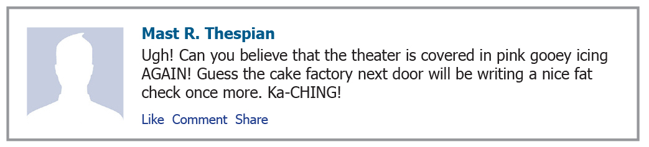

Do not comment on anything related to legal matters, litigation,
financial information or any parties The Rose may be in litigations or negotiations with.

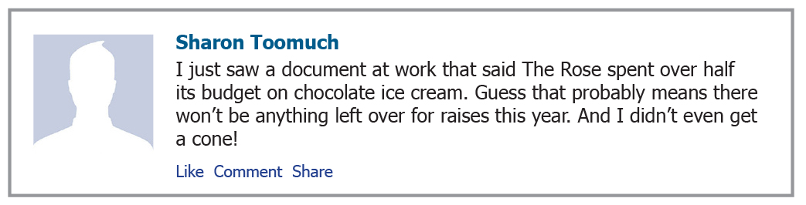

Do not comment on financial information, internal reports or other internal, business-related communications.

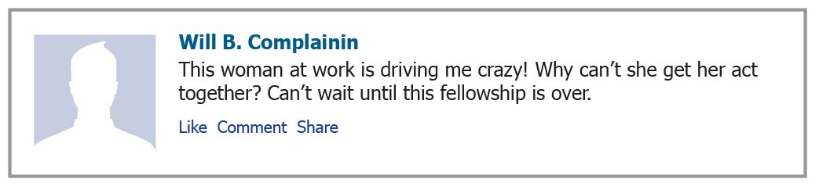

Do not post offensive remarks about fellow employees, customers, members, students, contractors, suppliers or people who work on behalf of The Rose. Resolve work-related complaints by speaking directly with co-workers.
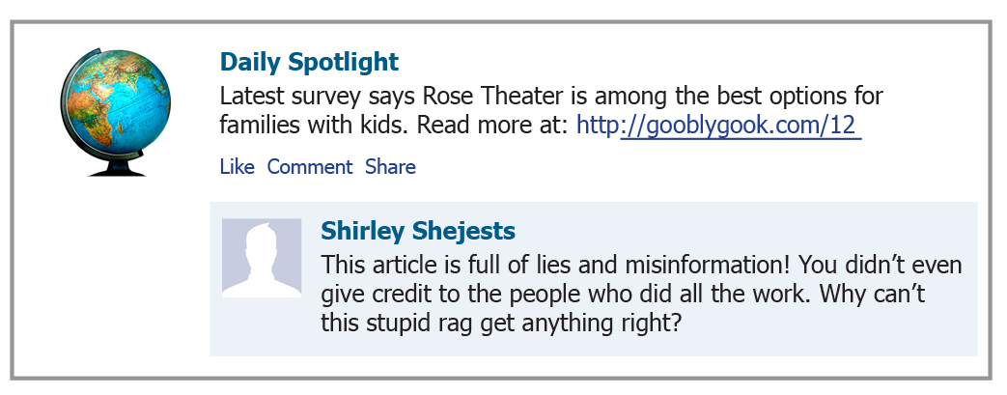

Do not post harsh or disparaging comments. Refer errors to the Marketing Department whenever possible. If you must correct someone who has posted incorrect information, do so in a way that is courteous and to the point. Keep it appropriate and polite. Better yet – send a private message to the individual or take it off line.

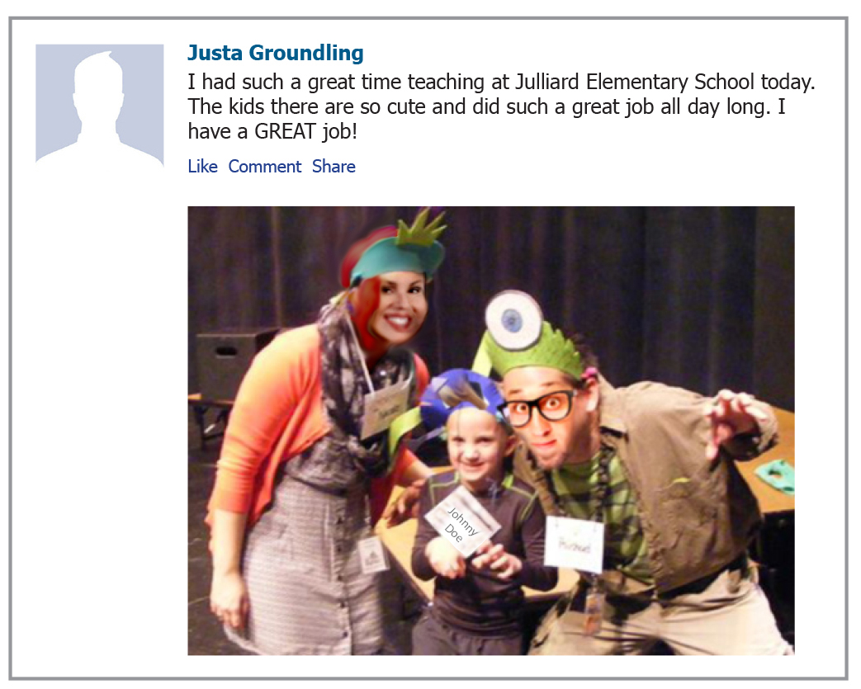

Do not post photos of students under age 18 to your personal social media site. Do not post photos of any individual without a signed consent form. Do not post photos of children with identifying information, such as a nametag or personalized clothing.

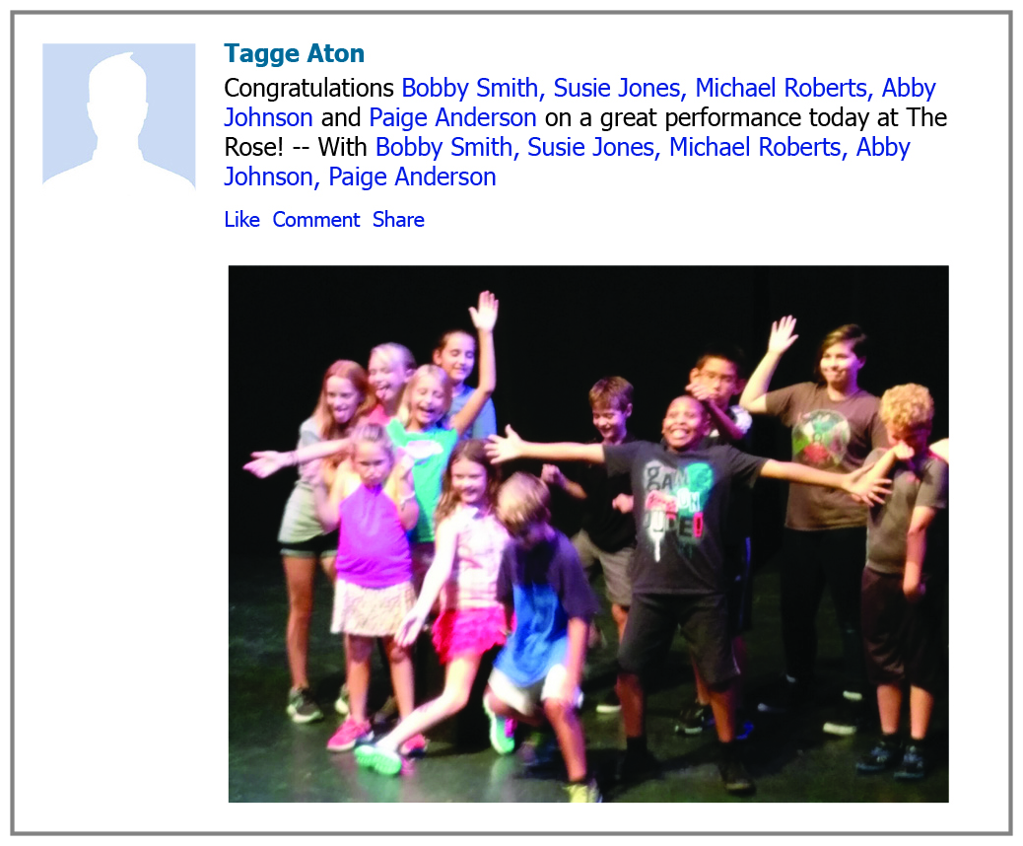
Do not tag students in posts. Do not include the last name of children in posts.

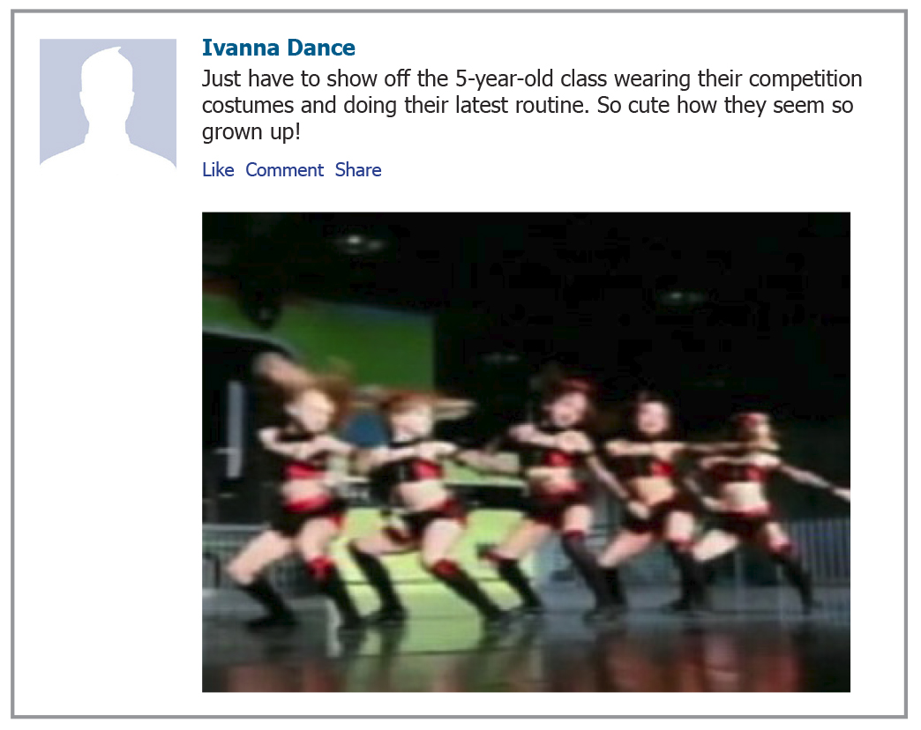
Be careful that photos and videos could not be misconstrued in a way that children are viewed as being dressed, posing or performing in provocative ways.

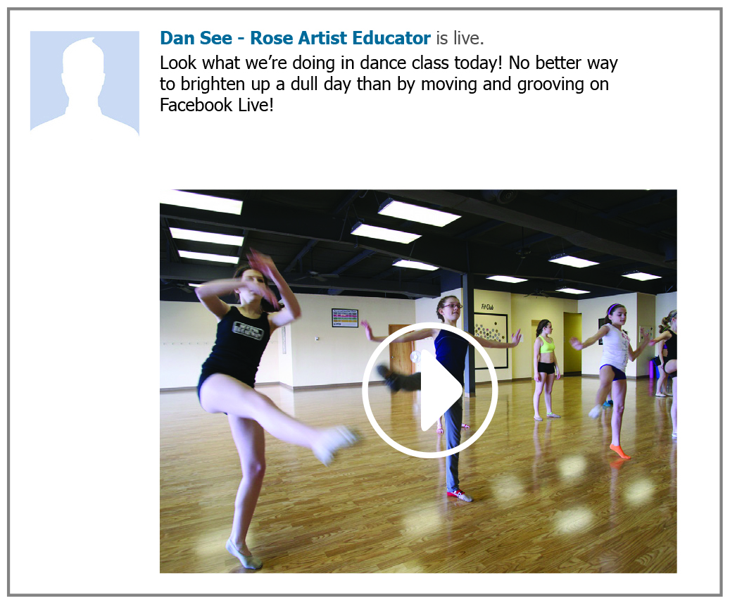
Do not live stream classes or images of students.

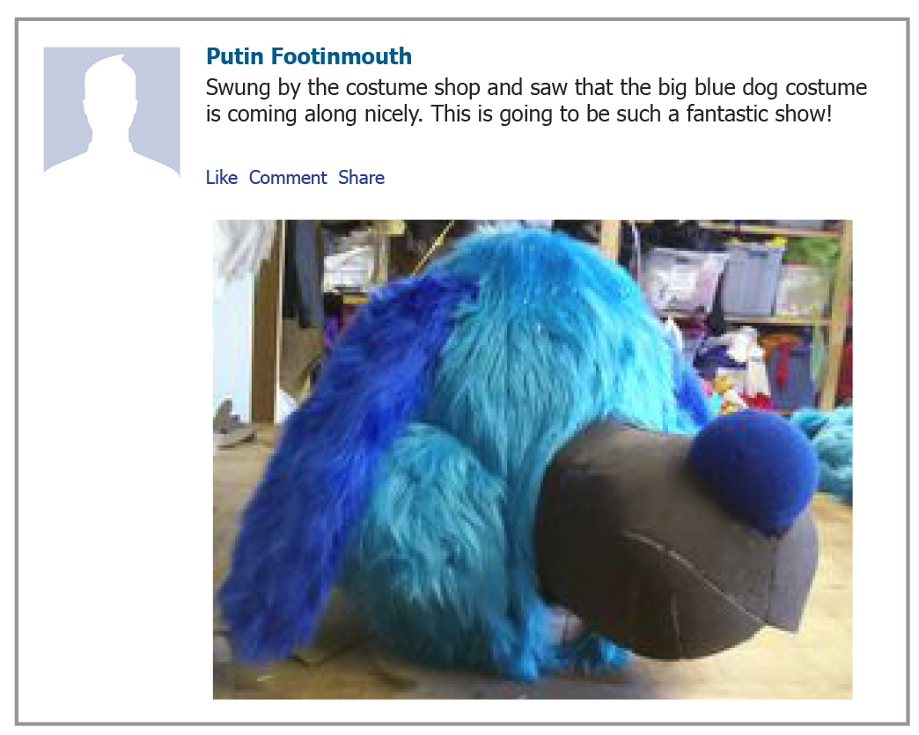
Be respectful of people’s work. Do not post photos of unfinished work online without the permission of the director and designer.

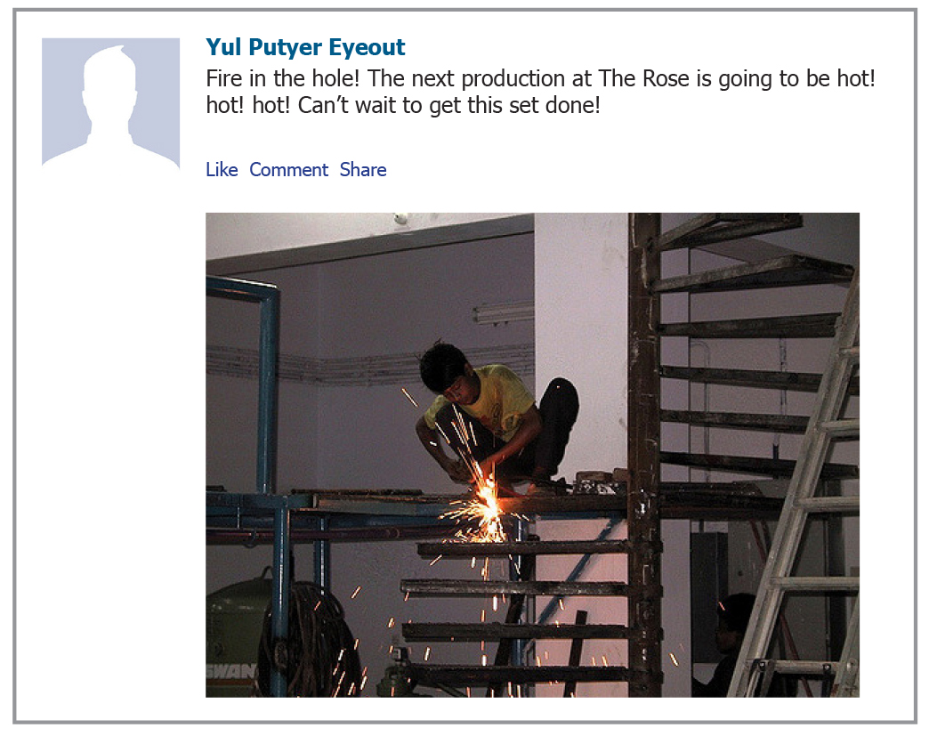
All photos posted on social media should show proper safety protocols, with staff and students wearing appropriate safety equipment.

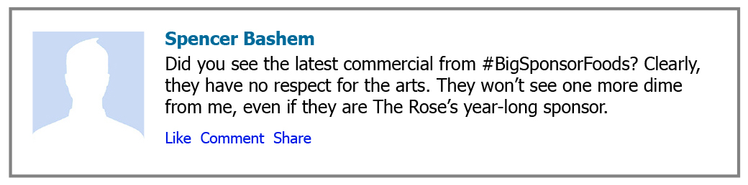

Be positive on social media. If an issue arises where a sponsor or donor to the theater needs to be educated on a topic, bring the issue to the attention of the Marketing Director, Managing Director or Artistic Director. If you feel you MUST comment, find a positive way to address the issue.

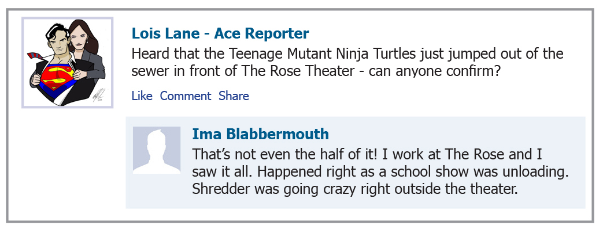

Do not communicate to the media without contacting the Marketing & Public Relations Director. Do not speak to the media on behalf of The Rose. Direct all media inquiries to the Marketing Department.

Use your best judgment

Perception is reality, and in online social networks, the lines between public and private personal and professional are blurred. Always use good judgment and common sense in deciding what you publish. If you are about to publish something that makes you even the slightest bit uncomfortable, review the suggestions above. If you are still unsure or uncomfortable, and it is related to Rose business, consider the cause of your discomfort and discuss it with your manager or the Marketing Director before you post.

Ultimately, however, you have sole responsibility for what you post or publish in any form of online social media.

