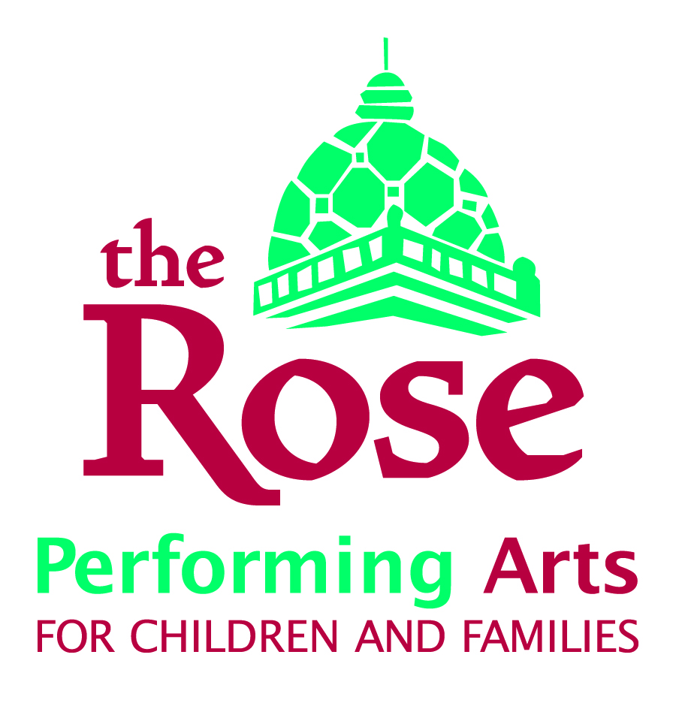

Performance Evaluation & Development Plan

Fiscal Year ___________

Employee: ___ __________________________________ Date of Hire:
Department: _ ____________ Job Title: ___________
Supervisor: __ _____________________________ Date of Last Review:
Performance Rating Categories:
- Outstanding – consistently exceeds job expectations
- Commendable – exceeds minimal requirements of the job
- Meets Requirements – proficient in the job function
- Needs Improvement – fails to perform the job at an acceptable level
- Unsatisfactory Job Performance – consistently fails to perform the job at an acceptable level; does not meet minimal requirements

Job Skills and Knowledge: Outstanding Commendable Meets Requirements Needs Improvement Unsatisfactory (circle one)
Skills and knowledge required for the job; ability to understand and fulfill the required duties, responsibilities, skills and procedures.
Comments: ___________________________________________________________________________
_____________________________________________________________________________________
_____________________________________________________________________________________
_____________________________________________________________________________________

Work Habits: Outstanding Commendable Meets Requirements Needs Improvement Unsatisfactory (circle one)
Thoroughness and accuracy of work; time management; meets deadlines; attitude; reliability.
Comments: ___________________________________________________________________________
_____________________________________________________________________________________
_____________________________________________________________________________________
_____________________________________________________________________________________

Collaboration: Outstanding Commendable Meets Requirements Needs Improvement Unsatisfactory (circle one)
Cooperation and flexibility within and outside own department, which includes work with students, contract actors, guest designers and directors, parents and patrons; responds positively to supervision; actively contributes to department/organization goals; offers/accepts constructive criticism; treats all with respect and helps foster good group morale.
Comments: ___________________________________________________________________________
_____________________________________________________________________________________
_____________________________________________________________________________________
_____________________________________________________________________________________

Performance/Results: Outstanding Commendable Meets Requirements Needs Improvement Unsatisfactory (circle one)
The quantity, quality and general results of the work performed.
Comments: ___________________________________________________________________________
_____________________________________________________________________________________
_____________________________________________________________________________________
_____________________________________________________________________________________

- Please list the goals which were set during the last evaluation and their status. What goals were related to the Strategic Plan?

- What are your goals for next season? What goals are related to the Strategic Plan?

- Please list any training needs, conferences or other professional development opportunities you would like to pursue in the next year. What suggestions do you have for more long-term professional development plans?

Employee’s Signature ________________________________________ Date __________
Your signature does not necessarily mean you agree, but affirms this review has been discussed in detail between you and your reviewer.

Reviewer Signature ________________________________________ Date ___________

