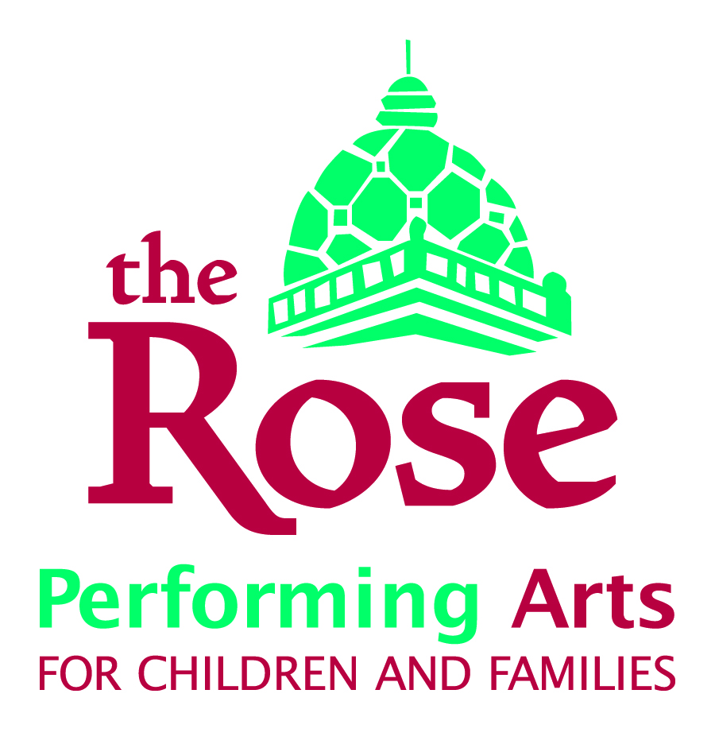
Review Questions for Employees
Name: __________________________________________________________________
Please be prepared the answer these questions for your supervisor during your meeting. Please think ahead of time and about each question and provide answers during your interview. Write answers ahead of time if you prefer. Written answers to the questions will be filed along with your evaluation. Thank you.
- What do you consider to be the most important accomplishments in your area of responsibility in the last year?

- List the strengths you bring to your position.

- What are your weaknesses and what are you doing to improve upon them?

- What additional ‘tools’ do you need to be as effective as possible?

- What, in your opinion, is a strategy or activity that would strengthen the company?

- How do you exemplify the core values of the organization? Are there examples from other departments, or ideas you have that you would like to incorporate in the future? [Core values: Young People and their families, Inclusion, Supportiveness, Play, Theater Education]

- What aspects of your job do you like the best?

- How much time would be valuable to you for creative, visioning or long-range planning time and what specifically would you do with that time?

When would you want to have that time set up in your schedule?

- Any other discussion topics not covered above?

