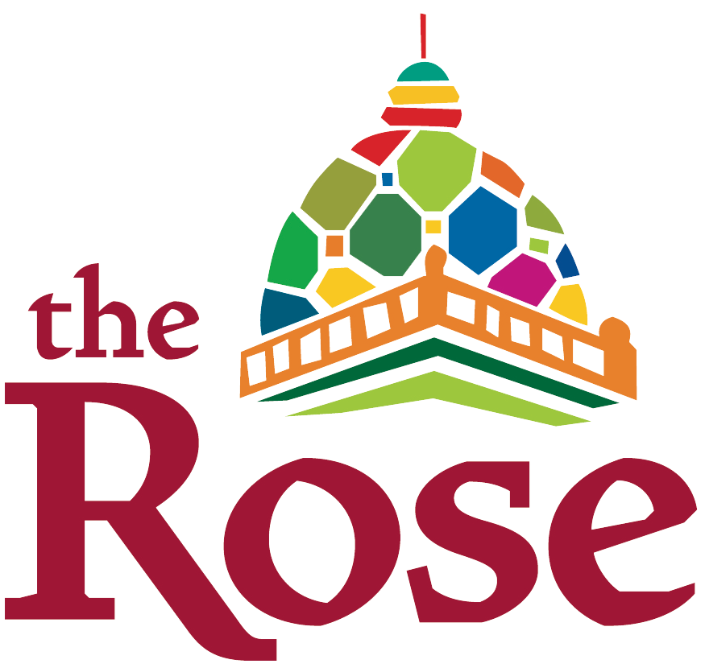

Brand Persona

The Rose Brand

Our brand is our most valuable asset. Our brand is the way our company is perceived in the community. It is what people think and feel about us. When a customer is making the decision whether to purchase tickets or enroll their child in a class, it is our brand image – everything they know about us, every experience they have had with us, every thought and feeling they have about us – that makes the difference between whether they decide to open their wallet or save their money for another spending opportunity.

Our brand is much more than just a logo. It is what we do. It is why we are in business. It is how we deliver programming. It encompasses our motivations, our passions and pursuits, and our priorities.

In many ways, a brand is a personification of a product, service or an entire company. Like a person, it has a name, personality, character and reputation. Like a person, you can respect, like and even love a brand. You can think of it as a deep personal friend, or merely an acquaintance. You can view it as dependable or undependable, principled or opportunistic, caring or capacious. Just as you enjoy being around some people and not others, there are brands that you warm to and others that you do not. People have character…and so do brands.

When we create a brand, we are essentially giving voice to a character. To help define The Rose’s brand, we have asked employees to share who they feel The Rose would be if the theater were an actual person. The following is a compilation of the many different responses we received.

As each of us interacts with customers, students, guest artists, volunteers and more, we should keep this persona in mind. The brand personality should come through in every interaction with have with the public. It should drive our decisions and shape the conversations we have with others. It should come through when we write about The Rose, in marketing materials and online communications. By committing to this brand persona, we are adopting an active brand strategy that will strengthen The Rose’s image and help to continue the excellent reputation we have built over the years.

Who is The Rose?

The Rose brand can be represented by a character we will call Rose.

Rose is a young woman but an old soul, with a love of the classics and a taste for the ultra-modern. She has traveled the world and has chosen to settle down here in Omaha to be closer to the community she loves. She lives in a giant house she inherited from a benevolent aunt, and she takes great pride in caring for the architectural beauty.

Rose is just unconventional enough to be entertaining and make a lasting impression. She is Willy Wonka, Punky Brewster, Auntie Mame and Ramona’s Aunt Bea, plus a few other eccentric characters, all rolled into one. When she leaves, you wish she could stay. When she isn’t around, those who know her best share stories and laughs about the last time she was here. She is a joy to everyone she meets.

Rose’s curious nature has led her to a variety of jobs, giving her an understanding of many different subjects. At the core of her career, though, is a spirit of innovation. She loves being on the cusp of technology, constantly on the search for what will be the next “big thing.” She isn’t afraid to ask the tough questions because she knows it can lead her to something great. She is a natural leader.

Rose is known for her creative spirit and love of life. Her appearance echoes her creativity – she wears bright colors and bold patterns, funky jewelry and some crazy shoes. And she never passes by an amazing hat! She is always experimenting with hairstyles and colors – she never looks the same twice.

Art plays a huge role in Rose’s life. She is a fan of all sorts of arts – she enjoys going to the different museums in town, as well as to the zoo and, of course, all the theaters. She loves traveling where she can see new and crazy things and share her talents with others. Rose’s free spirit inspires her to make beautiful and innovative things. She documents her travels and experiences with a couple of completely overwhelmed bulletin boards covered with memories of the many fun adventures, experiences and accomplishments from her past – there’s barely any room left on the board at all, but Rose still plans to add more! She considers the board her “celebration explosion.” And her life has given her a lot to celebrate!

There is always music playing in Rose’s house – and in her classic VW bug -- because Rose loves to dance whenever the spirit moves her. Her iPhone is filled with everything from jazz to classical, the Beatles to rap…she appreciates it all for the art that it is. As far as music goes, with Rose, it really just depends on the day. Some days are jazzy with lots of classic sounds from the Big Band Era and be-bop while sitting around on a rainy day, making cool stuff out of foil and cardboard tubes. Some days are all about sitting around at the top of the tree house in the backyard listening to Top 40 Hits, debating with friends about whether “Everything is Awesome” is better than “Let It go” or Happy.” Some days are classical and feel Very Important and Historically Significant. And some days are about listening to some type of music that is completely new and different.
It goes without saying that Rose reads constantly. She feels there are just so many great books out there and only so many hours in the day! There are three or four halfway-read books on the desk, by the couch, on her nightstand…everywhere, really. The books include a new trendy Young Adult bestseller, a classic old tale or collection, and a favorite illustrated children’s book – and even a few sci-fi thrillers.

Rose has spiffed up her beautiful Victorian house with her own eclectic tastes; the house boasts bold colors and vibrant patterns in every room. Her home is comfortable – peppered with cozy couches and fluffy floor pillows that just invite guests to stay as long as they like.

And people DO love visiting Rose! Adults appreciate Rose because she is the type of person most of them can never be – she has never lost touch with her childlike wonder, but she also has an air of sophistication. Adults love coming to a party at Rose’s house, because they never really know what to expect. Rose throws some great parties!

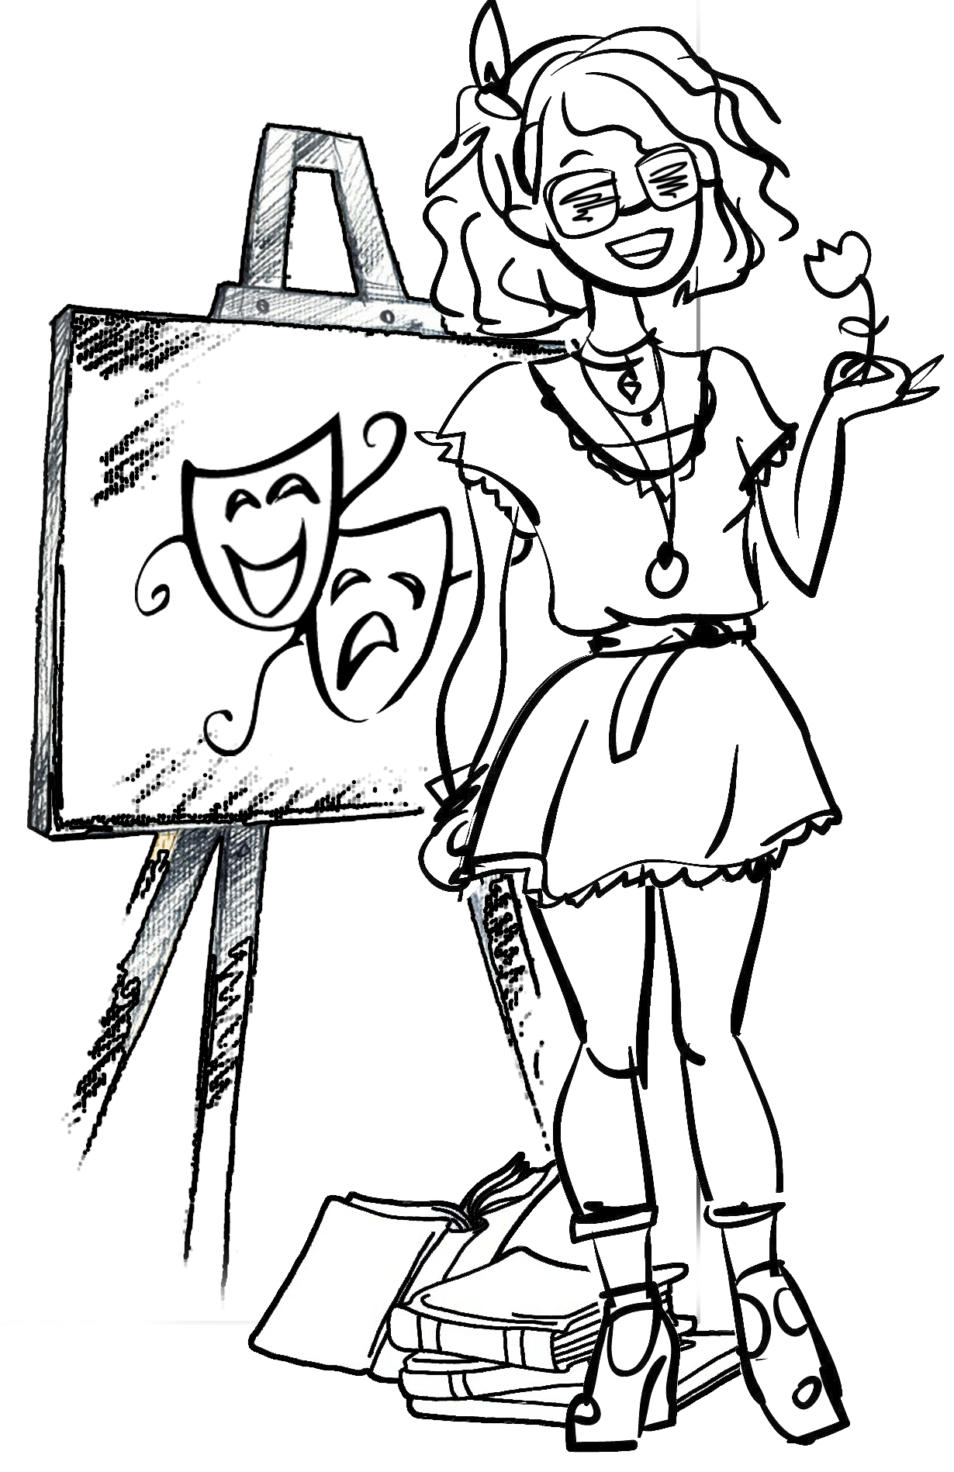
But it is kids who are truly enchanted by Rose! Rose’s young nieces and nephews can’t wait to visit Rose and her amazing home. Every visit is a new adventure. Rose understands her young friends because she is really just a big kid herself. She gets down on their level, she plays, she gets silly (and sometimes serious), she listens to what they have to say, she makes them feel important (because she honestly believes they ARE important). She makes blanket forts with tunnels throughout the entire house, she lets them explore the trunks in the attic for hidden treasures, she holds tea parties and leads pirate attacks, puts on puppet shows behind the couch, and she counts the stars with them on the swing in the backyard at night. She knows when it is time to slow down and talk about the big things, and her young friends know they can trust her to be honest and tell it like it is.

It is Rose’s trustworthiness that makes parents love her so much. They know that their kids are safe in Rose’s care. They realize that she can show their kids a part of the world that they have somehow lost.

Rose appreciates children’s innocence, but understands their sophistication at the same time. She introduces her young friends to all the best things in the world – she reads them her favorite classic books from her own childhood and listens intently as they read their favorite new books to her. She doesn’t mind when they stumble over words or have a hard time with pronunciation, because she understands that these kids are just learning, and sometimes, the best learning comes from their mistakes. She supports them through every new adventure and cheers them through their smallest victories. Rose knows that each of her nieces and nephews have special gifts and talents, and she does her part to make sure that they reach their full potential. And if they have the time of their life while they learn those lessons, Rose feels that she has done her job well.

Archetypes in Branding

Swiss psychologist Carl Jung used the word “archetype” to refer to the recurring patterns found in universal stories, identifying the themes, symbols and imagery as part of the human psyche. He believed that universal, mythic characters – archetypes – reside within the collective unconscious of people around the world. The archetype is a purposeful caricature, a positive stereotype. Jung explained that we intuitively “get” archetypes. They are shortcuts to meaning. They transcend time and place. We instinctively recognize archetypes in ourselves, other people, objects, situations and organizations, whether or not we are aware that we are doing so.

Archetypes can be used to understand the dynamics of a brand, as well.

This connection to an universality makes archetypes a powerful tool for branding, advertising and marketing. Dr. Carol Pearson has applied Jung’s work to a body of research that examined archetypal attributes within organizations and groups of people who are part of a culture and share a common purpose. Archetypes can help clarify where a brand is coming from, what it stands for and what its future potential might be.

In the book The Hero and the Outlaw, Pearson and Margaret Mark illustrate how the archetypes can be used by brands. They reveal that when these deep psychological imprints are understood and employed, brands not only gain meaning, but companies can also gain market share and increase shareholder value.

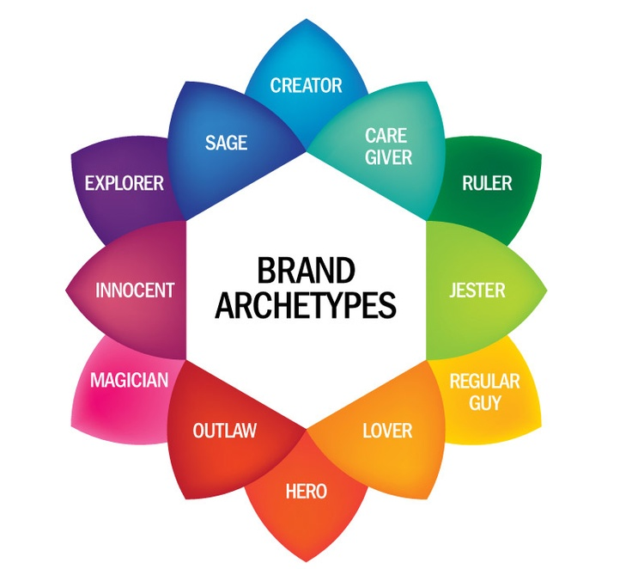
Jung identified 12 basic archetypes.

The Rose’s Primary Archetype: The Creator

As a theater company, The Rose naturally falls into the Creator archetype. The Creator archetype is expressive, imaginative and inventive. Creators are most fulfilled by seeing new ideas take shape. They enjoy demonstrating their inventiveness and often are able to motivate creative thinking in others. They are usually excited and challenged by opportunities to express themselves or advance new ideas.

With their nonlinear thinking, Creators are experts at seeing the big picture and rearranging disparate pieces to craft something meaningful. They offer a unique point of view on the world; Creator brands are innovative and promote self-expression. Authenticity is important of Creators who trust the creative process and believe in imagination. They give customers choices and options. Creators have a desire to create things of enduring value. They tap into the human imagination and are led by a vision. At the heart of the Creator’s passion is self-expression, most often in material form – they need to create something physical and tangible. Ultimately, what the Creator desires is to form a work of art so special that it will endure, and, in this way, the Creator achieves a kind of immortality. Creator brands are inherently non-conformist. What they stand for is not about fitting in, but about expressing something personal and deeply felt. Creators shape the world and define it. Because children are naturally creative, Creator-oriented brands appeal to children.

The Creator’s customers are interested in exploring their own minds and imagination. They have a desire to get something useful from their experience and to share it with others.

Basic tenets of the Creator archetype:

Motto: If you can imagine it, it can be done.
Core desire: To create things of enduring value
Goal: To realize a vision
Greatest fear: Mediocre vision or execution
Strategy: Develop artistic control and skill
Task: To create culture and express own vision
Weakness: Perfectionism, bad solutions
Talent: Creativity and imagination
Also known as: The artist, inventor, musician, writer or dreamer
What customers feel: “I want to do what s/he can.” Amazed. Inspired.

The Rose’s Secondary Archetype: The Magician

The Rose’s secondary brand archetype is the Magician, an archetype that isn’t afraid to dream big. The Magician uses his imagination to help make his idea a reality in the material world. He is most fulfilled when he can see a vision realized. The Magician is clever, gifted and blessed with powers that seem mysterious to others. He evokes amazement through his intuition and cleverness. He can make the impossible happen and can bring about wondrous change. Magician brands like The Rose provide services that are able to take their customers to another (literal or metaphorical) place.

Magician brands create a dynamic change by looking at issues with different eyes and presenting the customer with a new take or creative angle. They are highly innovative, promote transformation and exude charisma. Magician organizations believe in synchronicity, serendipity, miracles and mind-over-matter. As catalysts for change, they work to change situations and influence people. They are known for turning problems into opportunities and reframing difficulties. Magicians value transformational experiences and help turn ideas into action, empowering people, teams and networks.

Visiting a Magician organization like The Rose can be a magical experience, transforming adults into kids again and encouraging kids to trust their imagination. The Magician’s voice can be inspiring, symbolic and spirited. As a company in the entertainment business, The Rose can tap into its Magician’s ability to draw audiences into a whole new world, offering an escape from reality.

Basic tenets of the Magician archetype:

Motto: I make things happen
Core Desire: Understanding the fundamental laws of the universe.
Goal: To make dreams come true.
Greatest fear: Unintended negative consequences.
Strategy: Develop a vision and live by it.
Weakness: Becoming manipulative.
Talent: Finding win-win solutions, imagining a better future.
Also known as: The visionary, catalyst, inventor, charismatic leader, shaman, healer, medicine man, intuitive, wizard, inventor, transformer
Voice: Expansive, moving, articulate
What customers feel: “I want to experience that,” “I’m on the cutting edge,” fascinated, enchanted

